STORYBOARD TEMPLATE FOR SIMPLE / RAW 360° VIDEO
In this template you will find:
- Basic instructions on how to fill a storyboard template.
- An empty template.
- An example of filled template
Basic instructions
Before you start:
- List the characters (with abbreviations).
Example: Patient = P, Nurse = N, Family member = F.
- Choose the viewing perspective and justify it.
  - 1st-person (first view): the viewer sees from a character’s eyes (e.g., from the nurse’s perspective).
  - 3rd-person (third view): the viewer observes the scene from an external point of view.
Briefly explain why you chose this perspective and the intended effect (e.g., “1st-person to increase empathy and situational awareness”).
- Define the intended effect: describe the overall effect that you want to achieve with the 360° video. For example: taking the perspective of someone else; eliciting emotional responses; stimulating learners in noticing important aspects of a professional task.
For each scene, fill in every column
- Scene number and title
Number scenes in chronological order (1, 2, 3…) and give each a short, descriptive title.
- Estimated duration of scene
Write the planned length (e.g., “00:25”). To estimate, read the dialogue aloud with a timer and add a few seconds for actions or camera settling.
- Scene description
Cover the essentials:
  - Who is present? (use your abbreviations: P, N, F…). If relevant, provide a description of the actors
  - What are they doing? (key actions, interactions, emotions)
  - Where are they located? (room/setting; important objects/furniture the viewer might turn to see)
TIP: The more details you provide, the easier it will be to plan the materials needed for the video shoot and any instructions to give to the actors — for example, regarding nonverbal and paraverbal behavior. The fewer details you provide, the more the scene may develop in ways different from what you originally imagined.
- Oral script / Dialogues / Main message
Write dialogue with initials, or the voice-over if there is no dialogue.
Example: N: “Good morning, Ms. Rossi. How are you feeling today?”
(Note: in fully immersive 360°, heavy voice-over can reduce immersion—use only if it adds clarity.)
- Draft / photo or drawing of the scene
Add a quick sketch or reference photo(s). Indicate:
  - Approximate 360° camera position (height and distance).
  - Points of interest around the viewer (front, left, right, behind).
  - Any planned on-screen hotspots or visual cues.
Empty template
- Topic:
- Characters & abbreviations:
- Chosen perspective (overall):
- Rationale (intended effect):
Scene number and title | Estimated duration | Scene description  - Who?  - What?  - Where? | Oral script / Dialogues / Main message | Draft / photo or drawing of the scene
Example of filled template
- Topic: escalation of aggression from a patient with dementia during a home visit
- Characters & abbreviations: Patient (P, Mr. Rossi); Nurse (N); Student nurse / camera (S)
- Chosen perspective (overall): 1st-person from the student nurse (S)
Rationale (intended effect): Put the viewer “in the shoes” of the trainee to feel the heat, clutter, tension, and relational barriers first-hand.
Scene number and title | Estimated duration | Scene description  - Who?  - What?  - Where? | Oral script / Dialogues / Main message | Draft / photo or drawing of the scene
Scene 0 – Arrival of the nurse and the student nurse at the patient’s home – entryway | 15 seconds | • Who: Nurse and student nurse (at the door).  • What: They get ready to enter the patient’s home. The nurse briefly addresses the student about the patient they are about to visit.  • Where: Entry to the patient’s home (front door/entryway). | N: “Here we are. Let’s hope he’s awake and calm today… It’s usually quite chaotic! Come on, let’s go in and try to be quick. As soon as we enter, straight to the living room.” (the nurse looks at the 360° camera) | 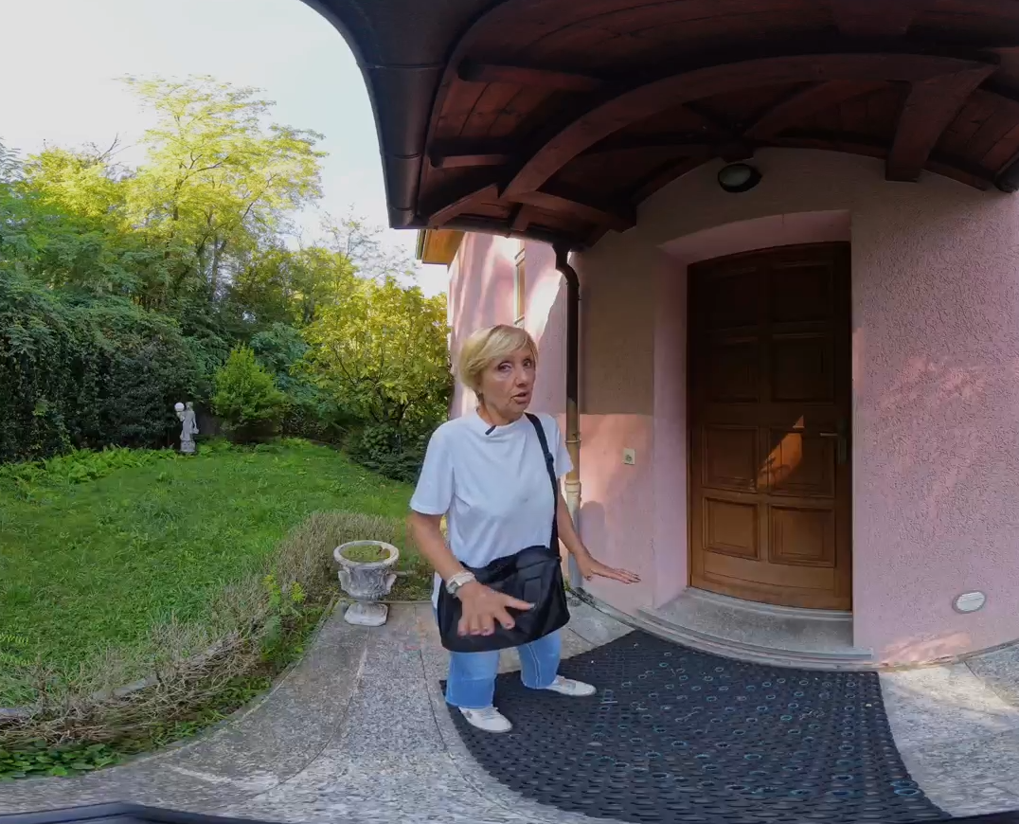
Scene 1 – Conducting the visit in the patient’s living room | 90 seconds | • Who: Patient seated on the sofa; nurse standing in front of the patient; the camera is placed next to the nurse and represents the student’s viewpoint (both nurse and student are standing).  Patient appearance: On the worn sofa sits an elderly man with a neglected look. He wears pajama pants, socks, and a loose, dirty undershirt. He is unkempt, unshaven, sweaty, with a dirty face, and shows clear signs of impatience.  • What: Initial contact and assessment; the patient shows irritability and discomfort.  • Where: Inside Mr. Rossi’s home, specifically the living room. There is a coffee table between the nurse and the patient; distance about two meters. The room is dimly lit by natural light with blinds half lowered. The air is hot and humid (the patient is sweaty; possibly the nurse as well, with hair tied back and damp at the nape).  Environment/props: The space is messy and dirty. The coffee table in front of the sofa has several dirty dishes. On the sofa and furniture there are clothes, towels, newspapers, food jars, full and empty bottles, a crate of water, toilet paper, a toothbrush, a radio, an alarm clock, bags (brioche/chips), etc. | N: “Good morning, Mr. Rossi, we’ve come for today’s check-up.” (neutral tone)  P: “Finally! I’ve been waiting for you all morning.” (gruff)  N: “Yes, we’re sorry for the delay.”  P: “There are two of you today?! Two to stare at me?!” (looking at the 360° camera)  N: “This is a nursing student from the School of Nursing and will be with me today. They’re just observing.” (technical tone)  P: “What do you want? Always so nosy, such busybodies! This isn’t a circus!” (staring at the 360° camera)  N: (looking around) “The house is really messy… and it’s sweltering in here. It’s too hot. Have you eaten anything this morning?”  P: (non-verbal irritation; gaze shifting between the nurse and the 360° camera)  N: “Haven’t you had anything to drink today? Have some water—and this fruit juice.” (directive tone; the nurse refers to the items on the coffee table)  P: “I don’t want anything! And why is that here?” (pointing at the 360° camera) “Are they here to learn how to be a nuisance?”  N: “They’re here to learn; no one is here to bother you.” (annoyed) | 