TEMPLATE FOR ACTIVE POINTS
(To be used together with the “Storyboard Template for Interactive 360° Video”)
Purpose
This template is designed to complement the main storyboard.
We recommend drafting your scenes first using the Storyboard Template for Interactive 360° Video (with Active Points), and then completing this template to describe each active point in greater detail.
In this document you will find:
- Basic instructions on how to complete the active points template
- An empty template
- An example of a filled template
Instructions for completing each active point
1. Provide a visual overview
Include a screenshot, sketch, or image showing how the active point will look like.
2. Time and position in the 360° video
Specify the exact moment and location where the active point becomes visible or interactive (e.g., 00:45 – next to the bed).
3. Media source
Select which resource(s) are linked to the active point:
☐ PDF ☐ Quiz ☐ Photo ☐ Video ☐ Move to another 360° scene ☐ Other
Briefly describe or name each resource.
Examples:
- PDF: “Hand Hygiene Checklist”
- Quiz: “Identify the Correct Communication Strategy”
- Video: “Short demonstration of safe equipment use”
4. Icon
Describe or include the icon used for the active point (e.g., info icon, play button, question mark).
If possible, attach a small image or reference the icon file name.
5. Learning objective of the active point
State what the learner should learn, practice, or reflect on when interacting with this point.
Use clear, measurable verbs.
Examples: Identify correct patient safety procedures; Apply principles of empathic communication; Recognize potential environmental hazards.
💡 Tips:
- Use action verbs such as identify, apply, recognize, analyze, decide, or reflect.
- Check the coherence with the overall learning objectives;

Empty template
Active Point | Time & Position in the 360° Video | Media Source (PDF / Quiz / Photo / Video / Other) | Icon | Learning Objective of the Active Point

Example of filled template
Active Point | Visual overview | Time & Position in the 360° Video | Media Source (Photo/Video/PDF/Quiz) | Icon | Learning Objective of the Active Point
N.0  0. Introduction | 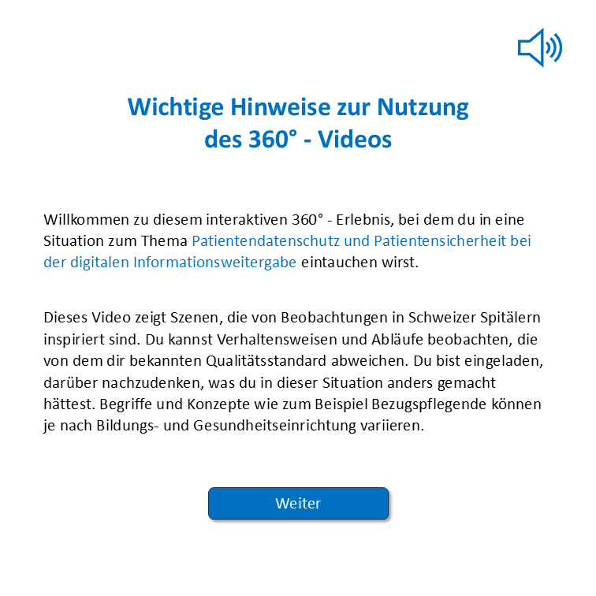  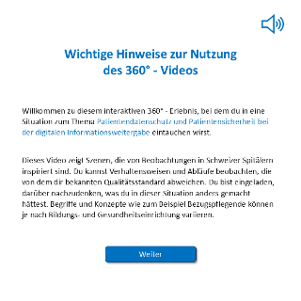 | At the beginning of the video on the defibrillator | JPG image created with PPT  And 3 icons |      | Introduction part / Principle of pre-training
N.1  1. Transmission in the aisle | 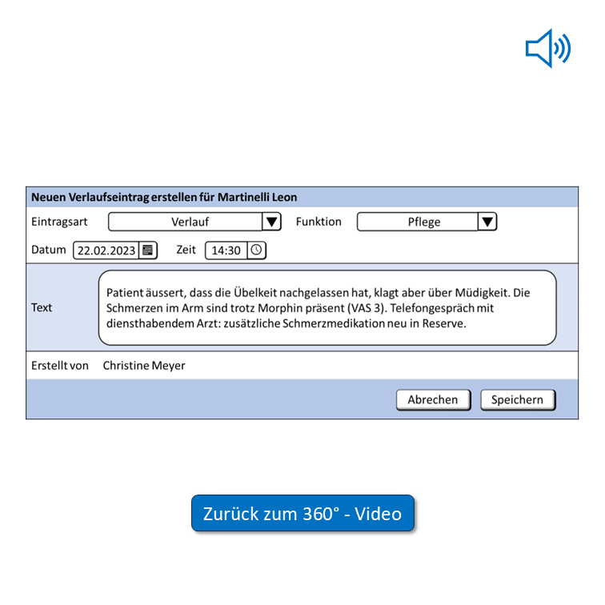 | On the nurse C. laptop 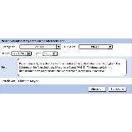screen, time time 00:00, seconds 15 | JPG image created with PPT  And 3 icons:  - Icon for open active point  - Icon for repeat the audio transcription  - Icon for return at the 360° video |    | Showing relevant information in the progress note
N. 2 | 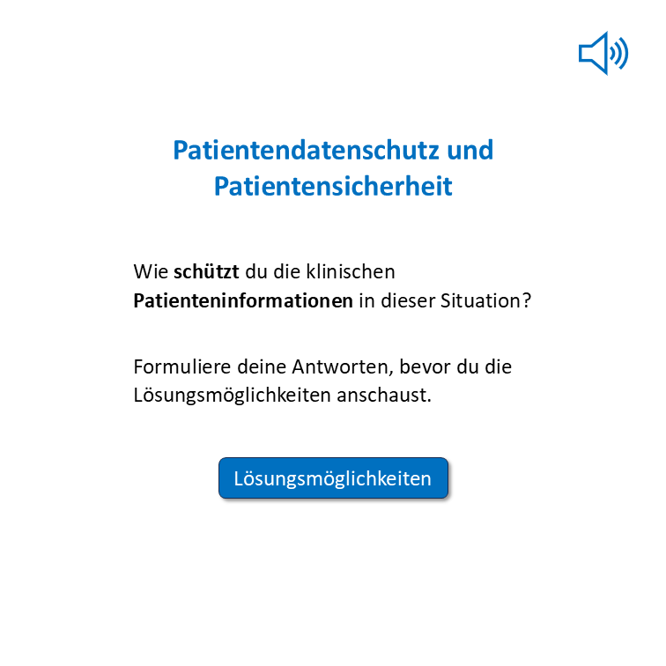 | On the nurse C. laptop screen, time 00:29,  Reading time: 15 seconds | JPG image created with PPT  And 3 icons:  - Icon for open active point  - Icon for repeat the audio transcription  - Icon for proceed to the answer |    | Making students reflect on the strategies to adopt to protect patient data from third parties
N.3 | 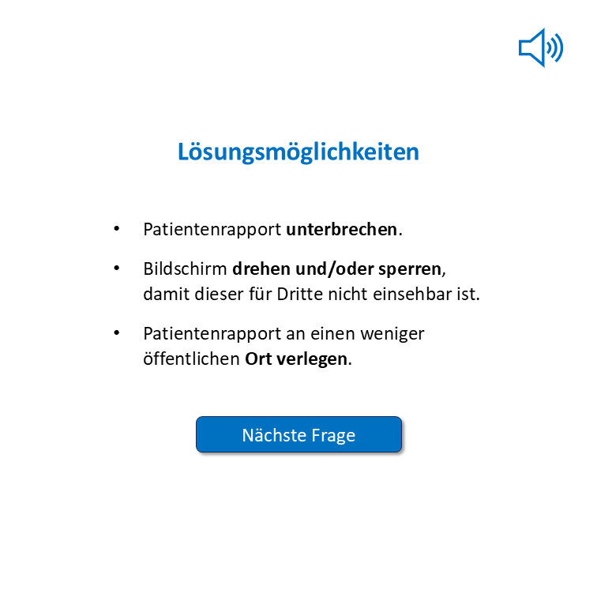 | After press the icon “Lösungsmöglichkeiten” active points N.2  Reading time: 15 seconds | JPG image created with PPT  And 2 icons:  - Icon for repeat the audio content  - Icon for proceed to next question |  | Display the correct response after reflection.
N.4 | 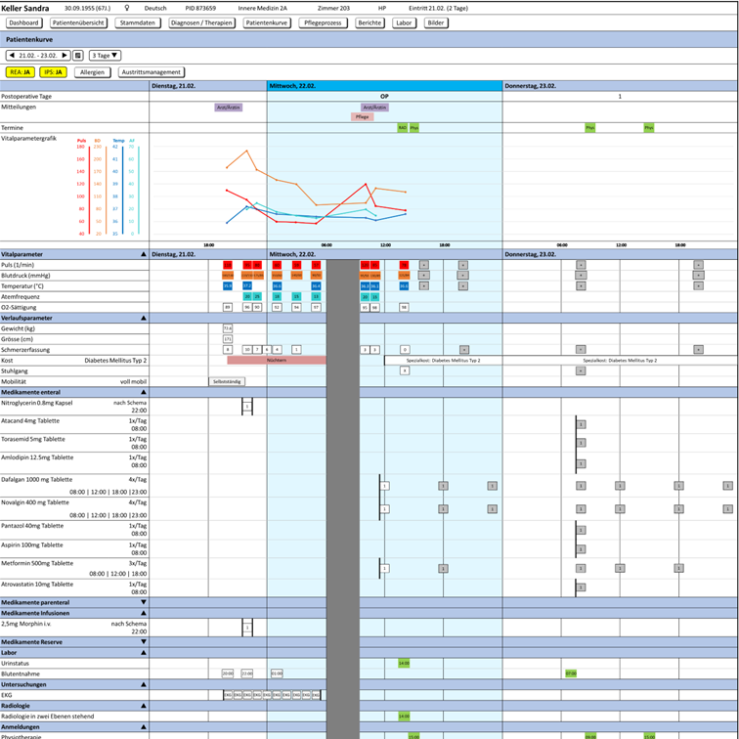 | Christine laptop screen, time 00:53  Reading time: 20 seconds | Video that shows a cursor that clicks on the time of the lab order in the “patient chart screen” to open “the laboratory order”  And 1 icon for open active point |  | Showing the complexity of a kind of informatic information system

