STORYBOARD TEMPLATE FOR INTERACTIVE 360° VIDEO (with active points)
In this template you will find:
- Basic instructions on how to fill a storyboard template for interactive 360° video (with active points)
- An empty template
- An example of filled template
Before you start
- List the characters (with abbreviations). Example: Patient = P, Nurse = N, Family Member = F
- Define the intended effect: Describe the overall effect you want to achieve with the 360° video (e.g. taking another person’s perspective; eliciting emotional responses; helping learners notice key aspects of a professional task)
- Define the intended learning outcomes: e.g. being able to recognize sterile and non-sterile areas in an operating room
Instructions for filling in each scene
- Scene number and title: Number scenes in chronological order (1, 2, 3…) and give each one a short, descriptive title. Example: “Arrival at the Patient’s Home.”
- Estimated duration of scene: Write the planned length (e.g., “00:25”). To estimate accurately, read the dialogue aloud with a timer and add a few seconds for actions or camera transitions.
- Scene description. Include the essentials:
- Who is present? (Use your abbreviations: P, N, F…) — add short actor descriptions if needed.
- What are they doing? (Key actions, emotions, interactions.)
- Where are they? (Describe the room or setting; mention objects or areas the viewer can look toward.)
- Perspective: Is it first-person (camera = learner’s eyes) or third person (external observer)?
💡 Tip: The more detail you provide, the easier it will be to plan the materials for the shoot and brief the actors (especially regarding nonverbal and paraverbal behaviour). If too few details are given, the scene may evolve differently from what you envisioned.
- Dialogue / Voice-over: Write the dialogue using initials or provide the voice-over text if there is no spoken dialogue. Example: N: “Good morning, Ms. Rossi. How are you feeling today?” (Note: In fully immersive 360° videos, excessive voice-over can reduce immersion — use it only when it adds clarity.)
- Draft / Photo / Drawing of the scene: Insert a sketch, draft, or reference photo showing what the viewer will see.
- Main media to be used: Tick the appropriate box: ☐ 360° video ☐ Panoramic photo
💡 Tip: Use 360° video for dynamic scenes and panoramic photos for static settings or informational hotspots.
- Active Points / Add-ons. Indicate whether any add-ons (interactive or non-interactive) are present in the scene.
☐ No add-ons
☐ Yes, non-interactive — e.g., visible arrows, circles, or animations that provide visual guidance but cannot be clicked.
☐ Yes, interactive — e.g., clickable icons or hotspots that trigger actions such as:
  - Opening a PDF or document
  - Starting a quiz or explanation video
  - Navigating to another room or viewpoint
- If yes, briefly describe each add-on: What does it look like? What is its purpose? What happens when the viewer clicks on it?
💡 For scenes containing clickable active points, please also complete the separate “Storyboard for Active Points” template, providing detailed descriptions of their content and behavior.
Empty template
- Topic:
- Characters & abbreviations:
- Rationale (intended effect):
- Learning outcome:
Scene number & title | Estimated duration | Scene description (Who / What / Where / Perspective) | Oral script / Dialogue / Main message | Draft / Photo / Drawing | Main media☐ 360° video ☐ Panoramic photo | Add-ons present? ☐ No ☐ Non-interactive ☐ Interactive | Description of add-ons (if any)

Example of filled template
- Topic: Shift handover
- Characters & abbreviations: two nurses: Christine (C) and Luca (L); Mrs Keller (MK);
- Rationale (intended effect): analyse and reflect on a concrete situation from practice
- Learning outcomes: information and data literacy and data management competences
Scene number & title | Estimated duration | Scene description  (Who / What / Where / Perspective) | Oral script / Dialogue / Main message | Draft / Photo / Drawing | Main media  ☐ 360° video ☐ Panoramic photo | Add-ons present? ☐ No ☐ Non-interactive ☐ Interactive | Description of add-ons (if any)
0. Introduction | Static scene (it depends to the viewer) | Is a first view perspective, in the corridor of the hospital. There is nobody. | - |  | Panoramic photo | Yes, one interactive point | Introduction part, principle of pre-training  
1. Transmission in the aisle | 2 min | It is a third view perspective, in an aisle of the ward, in front of the door of the patient's room. There are 3 actors (two nurses L. and C., and a visitor who appears for a short moment)  C. stands in the aisle of the ward in front of a patient room (M.K.). She stays in front of her nursing trolley and writes a «progress note» about the condition of a patient in the patient's electronic medical record in the clinical information system (CIS).  Her colleague from the morning shift, L., comes up to her with his nursing trolley and stops next to her.  C. has not yet been in the patient's room. L. takes his worklist and starts to describe the diagnosis and the patient's progress. | C. is typing a progress note for another patient.  L. asks: Have you already been in M.K.'s room?  C. continues writing the progress note while she's answering: No.  L.: Okay. Should I start to tell you about M.K.’s condition?  C.: Yes, please.  L.: She had a PTCA, (percutaneous transluminal coronary angioplasty). She is doing well so far. | 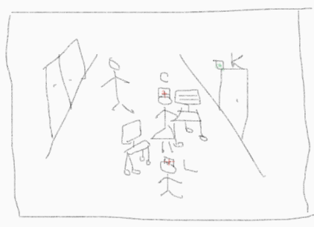 | 360° video | Yes, one interactive point | Clicking on an icon   a short video of a progress note with the following content:  Patient states that nausea has subsided but complains of fatigue. The pain in the arm is present despite morphine (VAS 3). Telephone conversation with doctor on duty: new additional pain medication in reserve.
1. Transmission in the aisle | 2 min | A patient who is walking along the aisle passes close to the nurses who are exchanging information. As the visitor passes by, the nurses stop their conversation, turn the nursing trolleys so that the screen is not visible to the visitor and greet him. | Silence.  L. & C.: Hello Sir! |  | 360° video | Yes, one interactive | Clicking on an icon  positioned on C.’s laptop, an image opens with following question:  1. How do you protect clinical patient information in this situation?  Formulate your answers before looking at the possible solutions.
2. PCI transmission in the patient’s room | 3’ | It is a third view perspective video, there are 4 actors (two nurses L., C., the patient M.K. and a physiotherapist who appears briefly and asks for C.’s attention)  L. enters the patient room first without his nursing trolley he activates the call light button in the room and goes to the patient's bed. C. follows him with her nursing trolley, leaves it a little away from the bed and goes to the foot of the bed.  *L. checks the pulse with his two fingers (index and middle finger)  C. *goes closer to the patient's bed*: Let's see. *She touches M.K.'s fingers to see if they are warm and supplied with blood.* | L.: Hello M.K., are you sleeping?  M.K.: Yes, I didn't sleep well  C.: Hello. My name is Christine Meyer, I’m a nurse and I will be responsible for your care today, until 10:30pm.  L.: How are you? Do you have any pain?  M.K.: Good, actually, I don’t feel any pain, just my hand feels a little bit numb.  L.: Ok, we will look at your hand, by checking your pulse and then we will start with the shift handover, alright?  M.K.: That is good, that is good.  M.K.: Your hand is warm…  C.: Do you have the impression that your hand is a bit cold?  M.K.: Yes, a little bit. | 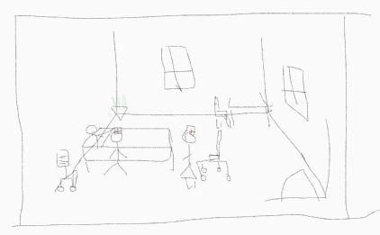 | 360-degree video | No

